**Case Studay 1**

**Case studies questions, answers and visualizations**

---------------------------------------------------------------------------------------------------------------------------------

**Q1)Total Sale Price**

**Solution:**

measure: total_sale_price {

type: sum

value_format_name: usd

sql: ${TABLE}.sale_price;; // sql: ${sale_price};;

}

---------------------------------------------------------------------------------------------------

**Q2)Average Sale Price**

**Solution:**

measure: average_sale_price {

type: average

value_format_name: usd

sql: ${sale_price} ;;

}

//Measures with Looker aggregations (sum, average, min, max, list types) may not reference other measures.

// sql: ${TABLE}.total_sale_price;;

-----------------------------------------------------------------------------------------------------

**Q3)Cumulative Total Sales**

**Solution:**

measure: cumulative_total_revenue {

type: running_total

sql: ${total_sale_price} ;;

}

------------------------------------------------------------------------------------------------------

**Q4)Total Gross Revenue**

**Solution:**

measure: total_gross_revenue {

type: sum

value_format_name: usd

sql: ${sale_price} ;;

filters: [status: "-Cancelled,-Returned"]

}

-------------------------------------------------------------------------------------------------------

**Q5)Total Cost // inventory_items.view**

**Solution:**

measure: total_cost {

type: sum

sql: ${cost} ;;

value_format_name: usd

}

//order_items.view

measure: total_cost {

type: sum

sql: ${inventory_items.cost} ;;

}

--------------------------------------------------------------------------------------------------------

**Q6)Average Cost:** //inventory_items.view

**Solution:**

measure: average_cost{

type: average

sql: ${cost} ;;

value_format_name: usd

}

//order_items.view

measure: average_cost{

type: average

sql: ${inventory_items.cost} ;;

value_format_name: usd

}

---------------------------------------------------------------------------------------------------------

**Q7)Total Gross Margin Amount**

Total difference between the total revenue from completed sales and the cost of the goods that were sold

**Solution:**

//total_revenue_from_completed_orders

measure: total_cost {

type: sum

sql: ${cost} ;;

}

measure: total_gross_margin_amount {

type: number

value_format_name: usd

sql: ${total_gross_revenue}-${inventory_items.total_cost} ;;

}

--------------------------------------------------------------------------------------------------------

**Q8)Gross Margin %**

**Solution:**

measure: gross_margin_percentage {

type: number

sql: ${total_gross_margin_amount}/${total_gross_revenue} ;;

value_format_name: percent_2

}

-----------------------------------------------------------------------------------------------------------

**Q9)Average Gross Margin**

Average difference between the total revenue from completed sales and the cost of the goods that were sold

**Solution:**

//total_revenue_from_completed_orders

measure: total_cost {

type: sum

sql: ${cost} ;;

}

measure: average_gross_margin {

type: number

sql: ${total_gross_revenue} - ${inventory_items.total_cost} ;;

value_format_name: usd

}

-----------------------------------------------------------------------------------------------------------

**Q10) Number of Items Returned**

**Solution:**

measure: number_of_items_returned {

type: count

filters: [status: "Returned"]

}

-----------------------------------------------------------------------------------------------------------

**Q11)Item Return Rate**

**Number of Items Returned / total number of items sold**

**Solution:**

measure:total_items_sold {

type: count

filters: [status: "Complete"]

}

measure: item_return_rate {

type: number

sql: ${number_of_items_returned}/${total_items_sold} ;;

value_format_name: usd

}

-----------------------------------------------------------------------------------------------------------

**Q12)Average Spend per Customer**

Total Sale Price / total number of customers

**Solution:**

measure: count_users {

type: count_distinct

sql: ${user_id} ;;

}

measure: average_spend_per_customer {

type: number

value_format_name: usd

sql: ${total_sale_price}/ ${count_users} ;;

}

------------------------------------------------------------------------------------------------------------------

**Q13)Number of Customers Returning Items**

Number of users who have returned an item at some point

**Solution:**

measure: number_of_Customers_returning_items {

type: count_distinct

sql:CASE WHEN order_items.status = 'Returned' THEN order_items.user_id ELSE NULL END ;;

}

SELECT

COUNT(DISTINCT CASE WHEN order_items.status = 'Returned' THEN order_items.user_id ELSE NULL END) AS filtered_order_items_count_users

FROM `cloud-training-demos.looker_ecomm.order_items`

AS order_items

LIMIT 500

-----------------------------------------------------------------------------------------------------------

**Q14)% of Users with Returns**

Number of Customer Returning Items / total number of customers

**Solution:**

measure: count_users {

type: count_distinct

hidden: yes

sql: ${user_id} ;;

}

measure: percentage_of_user_with_returns {

type: number

sql: ${number_of_Customers_returning_items}/${count_users} ;;

value_format_name: percent_2

}

-------------------------------------------------------------------------------------------------------------------

**Visualizations of this case study**

1)customer grouping contribute to Fashion.ly’s monthly revenue

Customer lifetime orders / total lifetime revenue

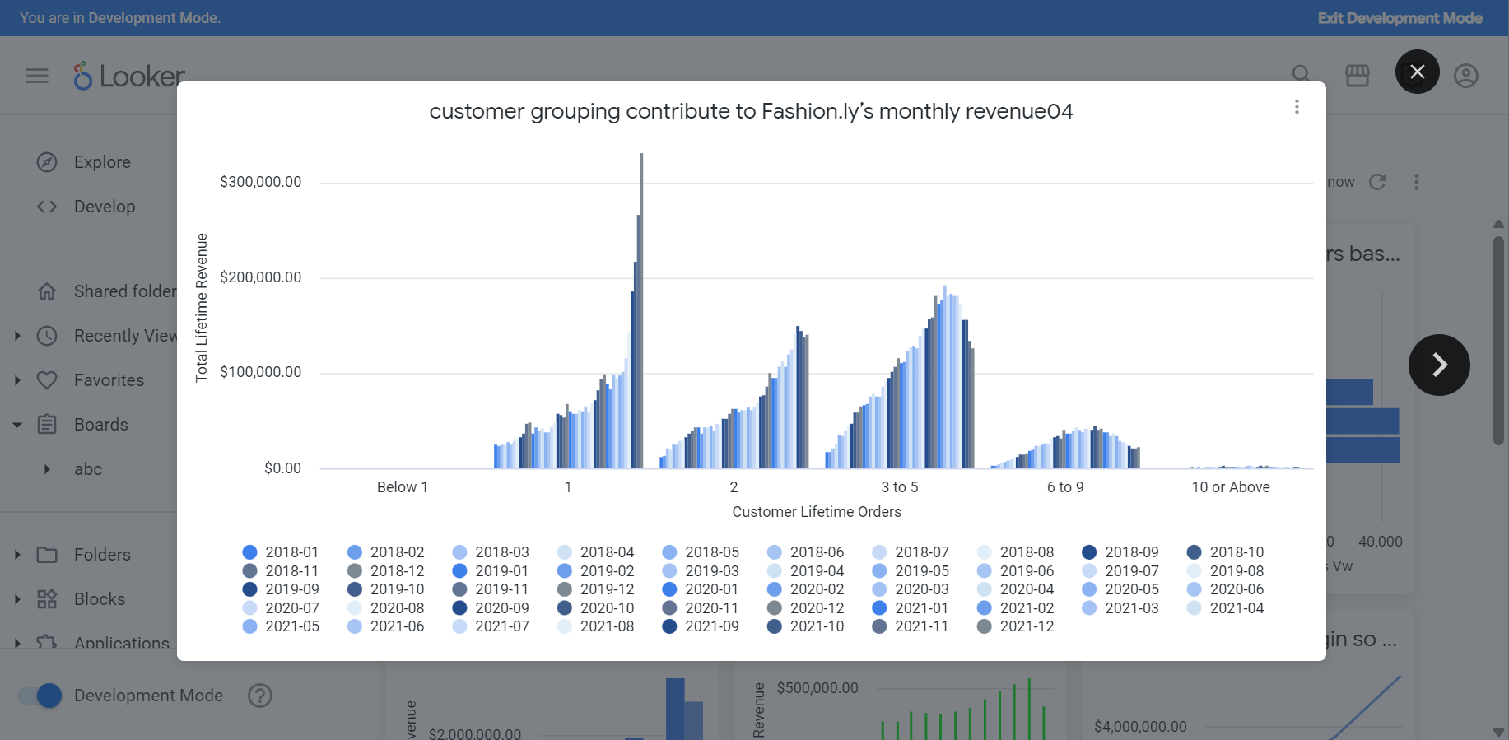

2) distribution of customers based on number of orders that they have placed

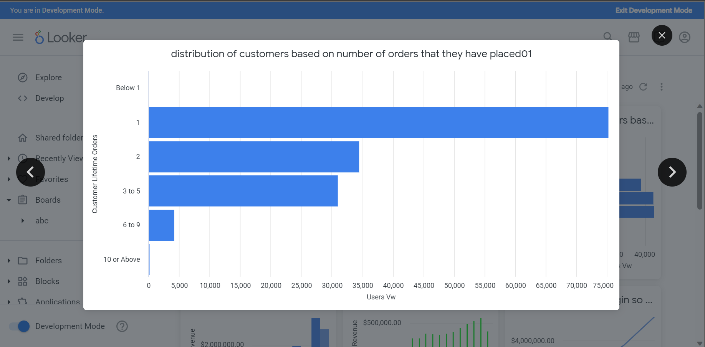

3) distribution of customers based on their lifetime revenue

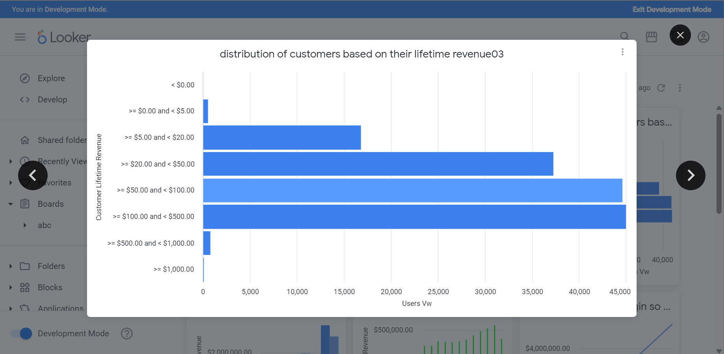

4) Gender wise sales on Yearly timeframe

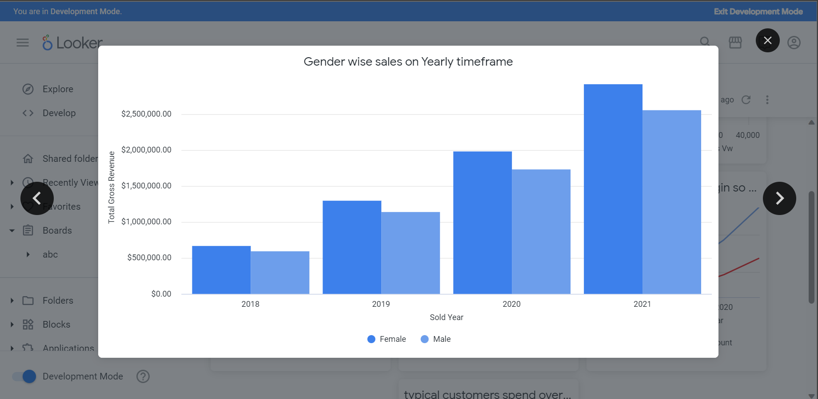

5) Month wise total Revenue for the year of 2021 based on different order status

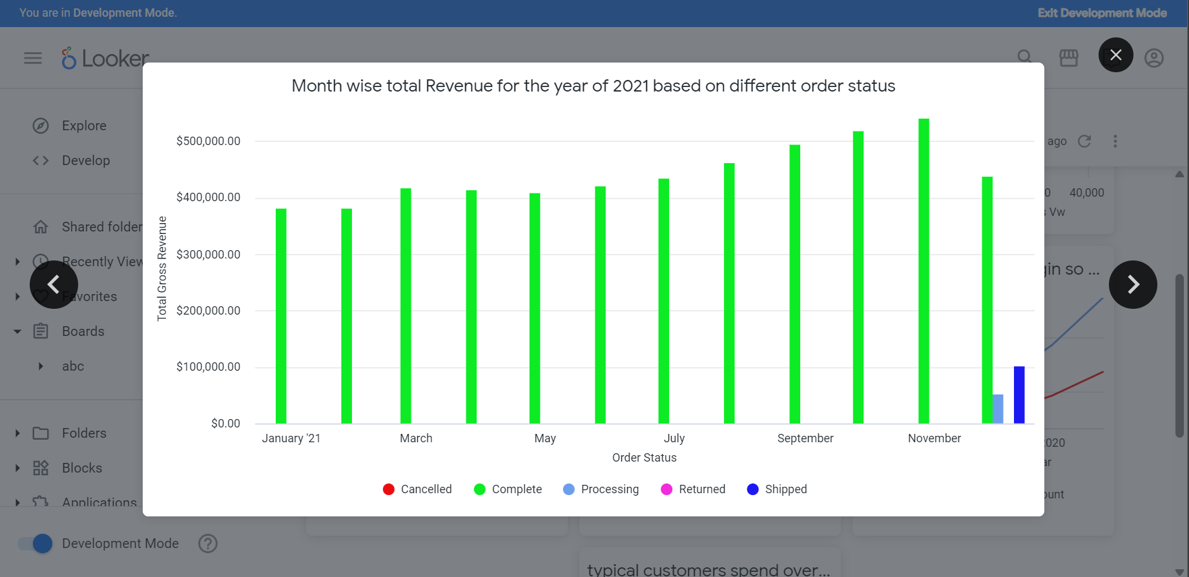

6) Total Revenue and Margin so that it can be compared and trend can be identified

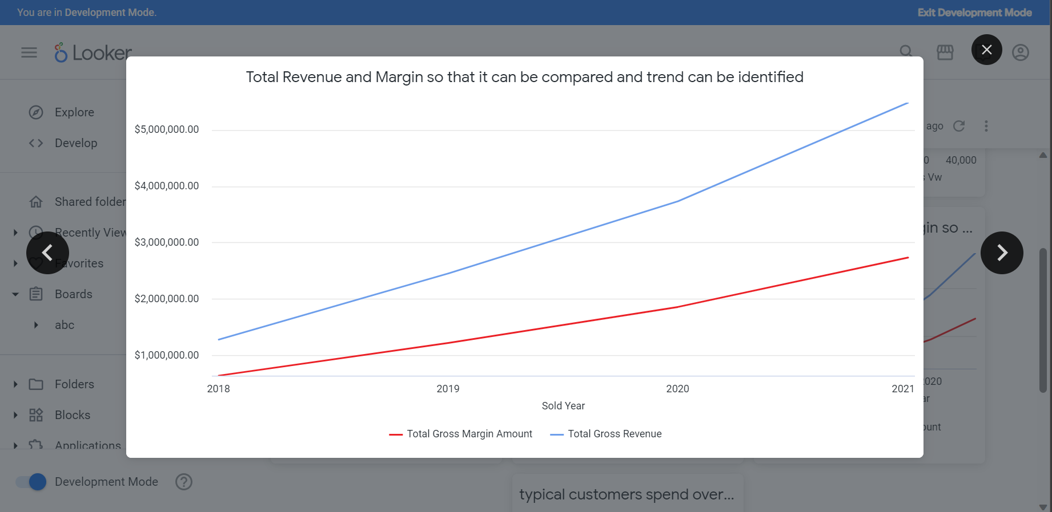

7) typical customers spend over the course of their lifetime as a customer

